Retrieval-Augmented Generation (RAG)
Retrieval-Augmented Generation (RAG) is an advanced AI framework that combines information retrieval with text generation models like GPT to produce more accurate and up-to-date responses. Instead of relying only on pre-trained data like traditional language models, RAG fetches relevant documents from an external knowledge source before generating an answer.
Retrieval-Augmented Generation (RAG) is an AI framework that improves LLM accuracy by retrieving data from external, trusted knowledge bases (internal documents, databases) to ground responses. It solves hallucinations and provides up-to-date information without retraining, making it ideal for enterprise applications.
Retrieval-Augmented Generation (RAG) is the process of optimizing the output of a large language model, so it references an authoritative knowledge base outside of its training data sources before generating a response. Large Language Models (LLMs) are trained on vast volumes of data and use billions of parameters to generate original output for tasks like answering questions, translating languages, and completing sentences. RAG extends the already powerful capabilities of LLMs to specific domains or an organization's internal knowledge base, all without the need to retrain the model. It is a cost-effective approach to improving LLM output so it remains relevant, accurate, and useful in various contexts.
Retrieval-Augmented Generation (RAG) is an AI framework that improves LLM accuracy by retrieving data from external, trusted knowledge bases (internal documents, databases) to ground responses. It solves hallucinations and provides up-to-date information without retraining, making it ideal for enterprise applications.
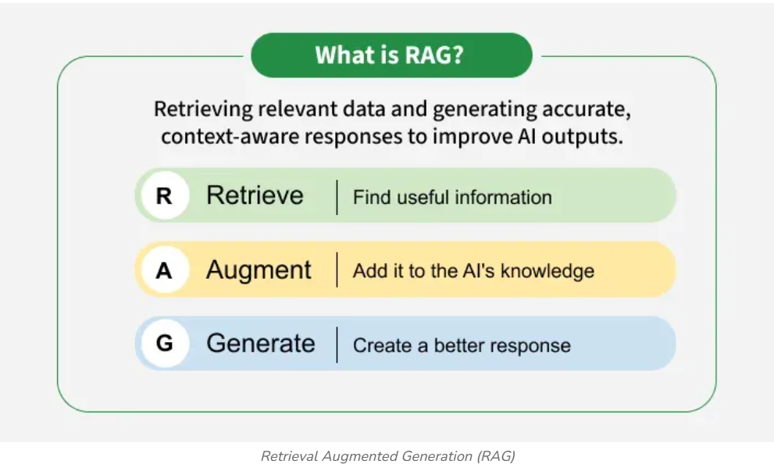
Retrieval-Augmented Generation (RAG) is the process of optimizing the output of a large language model, so it references an authoritative knowledge base outside of its training data sources before generating a response. Large Language Models (LLMs) are trained on vast volumes of data and use billions of parameters to generate original output for tasks like answering questions, translating languages, and completing sentences. RAG extends the already powerful capabilities of LLMs to specific domains or an organization's internal knowledge base, all without the need to retrain the model. It is a cost-effective approach to improving LLM output so it remains relevant, accurate, and useful in various contexts. RAG is an architectural approach to building AOI applications and services. RAG is a powerful architecture for improving the quality of responses from an LLM.

How does Retrieval-Augmented Generation work? (https://cloud.google.com/use-cases/retrieval-augmented-generation)
RAGs operate with a few main steps to help enhance generative AI outputs:
- Retrieval and pre-processing: RAGs leverage powerful search algorithms to query external data, such as web pages, knowledge bases, and databases. Once retrieved, the relevant information undergoes pre-processing, including tokenization, stemming, and removal of stop words.
- Grounded generation: The pre-processed retrieved information is then seamlessly incorporated into the pre-trained LLM. This integration enhances the LLM's context, providing it with a more comprehensive understanding of the topic. This augmented context enables the LLM to generate more precise, informative, and engaging responses.

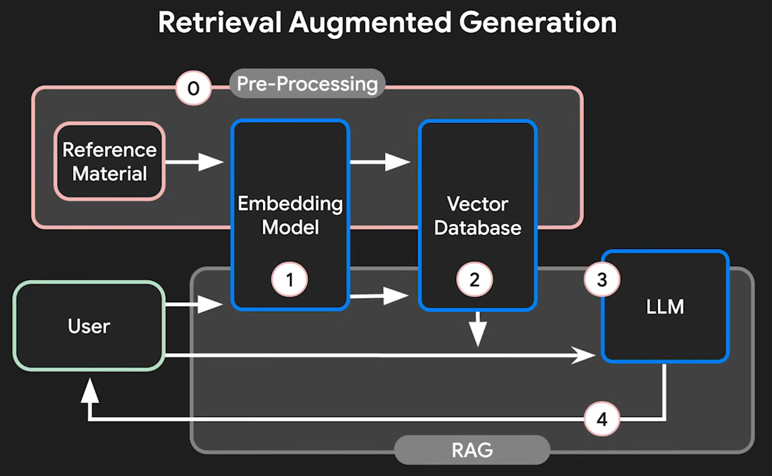
- Preprocessing (creating external data): We generate embeddings for all our data so it can be efficiently used by the system. Preprocessing is the action of preparing your files so that your RAG system can use them to generate the best possible answers.
- User Query: When a user asks a question, we generate an embedding of their query.
- Retrieve Relevant Data: We use the query embedding to search the vector database and retrieve relevant information.
- Augment the LLM prompt: The retrieved information is then added to the prompt and sent to the LLM to generate a response. This is the augmentation phase.
- Generate Response: LLM uses this augmented prompt, along with its existing knowledge, to generate a response. This is referred to as the generation phase. The LLM sends the generated answer back to the user as a response.

How does Retrieval-Augmented Generation work?
Without RAG, the LLM takes the user input and creates a response based on information it was trained on—or what it already knows. With RAG, an information retrieval component is introduced that utilizes the user input to first pull information from a new data source. The user query and the relevant information are both given to the LLM. The LLM uses the new knowledge and its training data to create better responses.
- Create external data (Pre-Processing):
- Retrieve relevant information:
- Augment the LLM prompt
- Response Generation
- Update external data
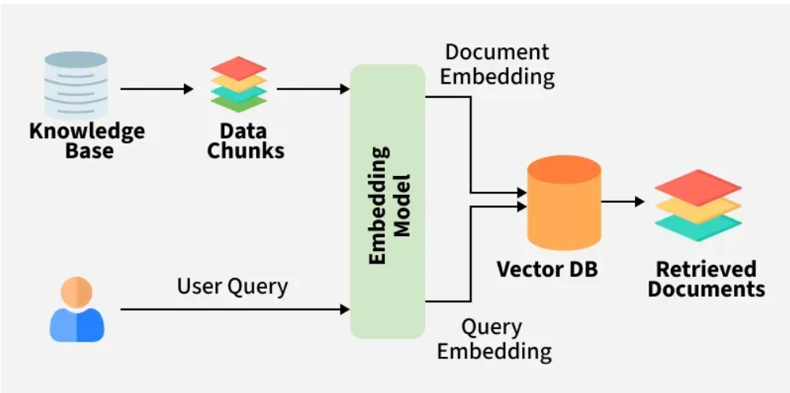

In order to understand how RAG works we need to break this down into 3 diff steps
1) Retrieval - Finding relevant information from the vector database
2) Augmented - Adding retrieved information (context) to the query
3) Generation - Producing the final response
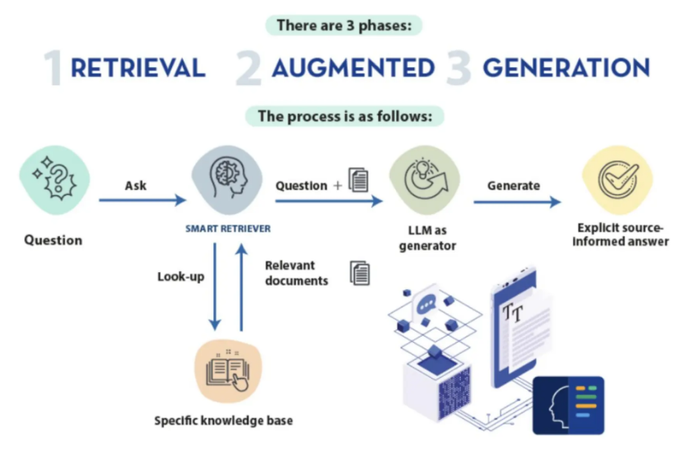
Retrieval: Starting with retrieval, just like how we converted the documents into vector embeddings to store them into the database, we do the exact same step for the user query. This query embedding is then compared with the embeddings of the documents that were previously stored. This method is known as semantic search, where instead of searching for exact keyword matches, the system uses the meaning and context of the user’s query to match it with relevant documents in the database. By focusing on the semantic content, this approach ensures that the system retrieves the most contextually appropriate information.
Augmented: Moving on to augmentation, in the context of RAG, this refers to the process where retrieved data is injected into the prompt during runtime. The retrieved information becomes the context added to the original user query as a guide for the generative AI model to generate factually grounded and relevant responses. You might wonder, what makes this so special? Typically, AI assistants rely on knowledge gained during pre-training, which is static and can become outdated very quickly. The goal with augmentation is to have the AI rely on real-time, up-to-date information from a vector database instead of outdated pre-trained knowledge. At runtime, the AI assistant can be provided with the most relevant and current information to help answer queries. In RAG, the results from semantic search are appended to the prompt, essentially augmenting the AI’s knowledge. The best part is that this can be achieved without needing to fine-tune the AI model or modify the large language model itself.
Generation: The final step of RAG is generation. In this stage, the AI assistant produces a response using the semantically relevant data that was retrieved from the vector database.
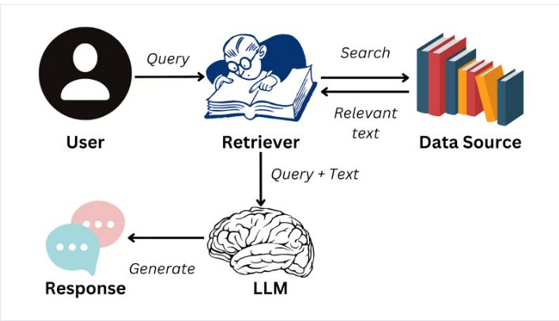

RAG is a very powerful system that can instantly enhance the depth of an LLM’s knowledge beyond its original training data.

Knowing how to chunk your data before storing them into the vector database is a critical decision that will determine the efficacy of rag. In order to set up a rag system, you have to employ different strategies like chunking strategy where you determine the size and overlap of each chunk, embedding strategy to decide which embedding model to use and to convert your documents into factor embeddings and retrieval strategy where you control the threshold of how similar the words need to be as well as additional filters that you might want to add in the data set.

RAG --- > Embedding model, embeddings, vectors, Vector Database (DB), preprocessing, Indexing, chunk (chunking), parsing, Data Indexing, semantics, Semantic search, vector search vs semantic search, context window
[AI agents Vs Agentic ai Vs generative AI]
In Retrieval-Augmented Generation (RAG), embeddings and embedding models are the foundational components that allow AI to understand, search, and utilize external, private data.
They act as the bridge between human-readable text and computer-readable numbers, enabling the "retrieval" part of RAG to go beyond simple keyword matching and understand semantic meaning

Embedding Model: An embedding model is a machine learning tool (e.g., neural network) that converts unstructured data like text, images, or audio into dense numerical vectors known as embeddings. The model learns to map data into a high-dimensional space where similar items are placed close together, transforming raw data into semantic representations. An embedding model takes text and converts it into numbers that represent meaning. One of the popular embedding model is sentence-transformers/all-MiniLM-L6-V2

Embedding models are the type of machine learning model designed to represent data in a continuous, low dimensional vector space called embedding. Embedding are numerical representation of a piece of information for like text, documents, images, audio etc. which captures the semantic meaning of what is being embedded which makes it robust for many industry applications.
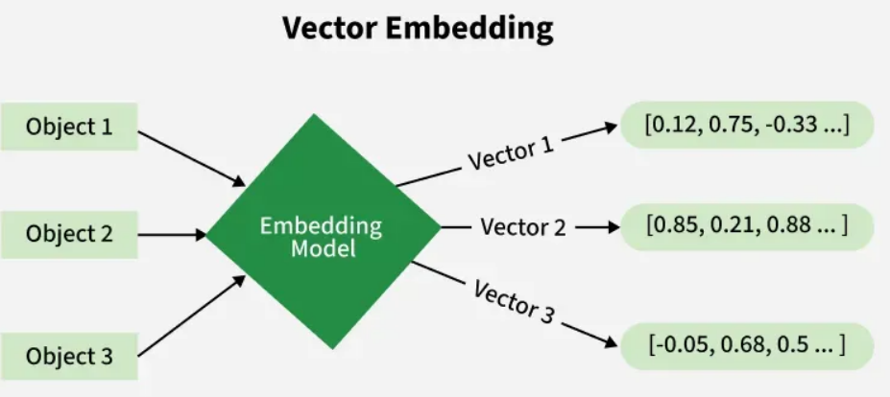
Here, each object is transformed into a numerical vector using an embedding model capturing semantic features and relationship between different data points.
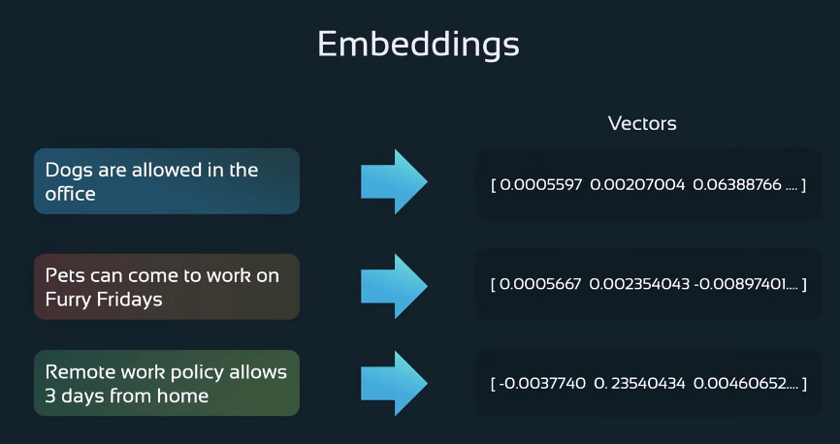

Working of embedding models
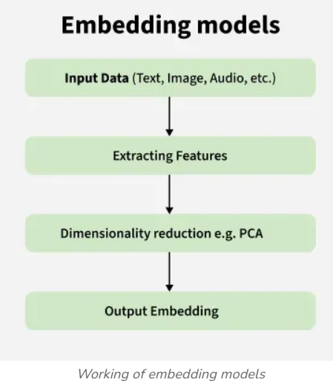
1. Input data
The process begins with raw input data which can be of any form such as text, images, or audio. This raw data is often unstructured and needs to be preprocessed to make it suitable for machine learning models.
2.Extracting features
Once the input preprocessing is done the next step involves extracting meaningful features that represent the underlying structure or patterns within the data. For textual data we can use models like Word2Vec, GloVe, or BERT. This stage transforms the data into a numerical vector representation that captures essential characteristics.
3.Dimensionality reduction
After extracting features the data exists in a high dimensional space which can be computationally expensive and prone to overfitting. Dimensionality reduction techniques like Principal Component Analysis (PCA) are used to reduce the feature space while preserving the most informative aspects which makes the resulting representation more compact and efficient.
4. Output embedding
The final output is an embedding which is a low dimensional vector that encodes important features in a machine understandable form. These embeddings are used in various downstream tasks such as classification, clustering, recommendation, and similarity search.

How do we choose the right embedding model?
1. Type of data
- The choice of embedding model heavily depends on the type of data you are working with.
- For text data models like Word2Vec, GloVe, or transformer-based embeddings like BERT are suitable.
- For image data convolutional neural networks (CNNs) or models like ResNet and can be used to generate embeddings.
- For audio, models like wav2vec are more appropriate.
2. Required task
- The specific task which you are trying to accomplish through embedding plays an important role in selecting an embedding model.
- For example if you need embeddings for sentiment analysis contextual models like BERT are often better than static embeddings.
- On the other hand if want to build a recommendation system, collaborative filtering or specialized recommendation embeddings may work better.
3. Speed and accuracy
- Larger and more complex models like BERT or CLIP give highly accurate output embeddings but require significant computational resources and time.
- We should choose the right balance between speed and accuracy which ensures that our application is both effective and efficient.
4. Size of dataset
- The volume of available training data also influences the choice of embedding model.
- Machine learning models like BERT performs best with large datasets while simpler models like Word2Vec are effective with smaller datasets.
- If our dataset is limited we can use pre trained embeddings from large models and fine tuning them on your specific domain we can get better performance without the need for extensive training data.

Embeddings:
Embeddings are numerical representations of inputs. You can use embeddings in your applications to recognize complex meanings and semantic relationships and to process and produce language.
Embeddings work by converting text, image, and video into arrays of floating point numbers called vectors. The closer two vectors are in their embedding space, the greater the similarity of their inputs.
Embedding models are an important component of semantic retrieval systems. The performance of a retrieval system depends on how well the embedding model maps relationships in your data.
Embeddings are the heart of a RAG system. If your embeddings aren’t appropriate for your data, you won’t be able to retrieve relevant data for the LLM to use to generate a response.
Vector is a mathematical structure — simply a list/array of numbers. Embedding is the representation of data (text, image, etc.) converted into a vector by a model
So:
- Vector → numerical format (array of numbers)
- Embedding → meaning-based representation of data stored as a vector
In simple terms
- Embeddings are vectors, but vectors are not always embeddings.
For example:
- A vector used in mathematics is just numbers.
- An embedding is a vector that represents semantic meaning of data (like a word, sentence, or document).

Data parsing is the process of analyzing, breaking down, and converting raw, unstructured data (like raw text, HTML, or logs) into a structured, machine-readable format (such as JSON, CSV, or a database entry). It enables software to interpret specific data points, extract relevant information automatically, and organize it for easier analysis.

Semantics in Retrieval-Augmented Generation (RAG) refers to the use of AI techniques to understand the intent, context, and meaning behind a user's query or input data for external knowledge base rather than relying on keyword matching.
In the context of RAG (Retrieval-Augmented Generation), semantic refers to the meaning or context of the information being processed. Specifically, semantic in RAG typically relates to the understanding of meaning in the data being retrieved and generated.
Semantics refers to getting meaning or context of the input data (such aa reference material or user query) into a vector embeddings and store those into database as vectors (due to which database is called vector database).
Chunking
Knowing how to chunk your data before storing them into the vector database is a critical decision that will determine the efficacy of rag. For example, legal documents require a different chunking strategy than customer support transcript documents. This is because legal documents often contain long, structured paragraphs that need to be preserved. On the other hand, conversational transcripts can work well with sentence-level chunking, using a high overlap to preserve context.
It is a crucial step in Retrieval-Augmented Generation (RAG) as it breaks down long documents into smaller, more manageable units. These units, called chunks or passages, are then used for efficient retrieval and provide more focused context for the LLM during response generation.
Advantages of Chunking:
- Improved Retrieval Efficiency: Smaller units allow for faster and more focused similarity searches in the vector database.
- Enhanced LLM Context: Chunks provide the LLM with more specific information for generating relevant and informative responses.
- Flexibility in Retrieval: Different chunks can be retrieved depending on the specific query, leading to more nuanced responses.
Disadvantages of Chunking:
- Information Loss: Chunking can lead to some information loss at boundaries.
- Increased Computational Cost: Chunking adds an additional processing step that may impact overall system speed.
- Tuning for Optimal Performance: Choosing the right chunking technique and parameters requires careful experimentation.
Chunking Techniques:
1. Fixed-Size Chunking:
2. Sentence-Based Chunking:
3. Sliding Window Chunking:
4. Recursive Character Text Splitter:
5. Embedding based chunking
6. NSP based chunking
7. Content-Aware chucking

Parsing Vs Chunking
In RAG, parsing and chunking are two different preprocessing steps, and they serve different purposes.
Parsing is the process of analyzing and structuring the raw document. It involves extracting the text from different formats such as PDFs, Word files, or HTML and identifying elements like headings, paragraphs, tables, or metadata. The goal of parsing is to convert unstructured or semi-structured data into a clean, organized format that the system can understand and process.
Chunking, on the other hand, happens after parsing. It is the process of splitting the parsed content into smaller pieces, or chunks, before generating embeddings. These chunks are created in a way that preserves meaning and context so they can be effectively stored in the vector database and retrieved later through semantic search.
In simple terms, parsing prepares and structures the document, while chunking divides that structured content into smaller, meaningful sections for embedding and retrieval.

Data Indexing in RAG:
Data indexing in Retrieval-Augmented Generation (RAG) is the critical process of transforming, structuring, and storing external data for fast, accurate retrieval, enabling LLMs to access relevant context. It involves loading documents, breaking them into smaller chunks, converting chunks into numerical vector embeddings, and storing them in a vector database for semantic search.
Indexing in terms of RAG is the process of organizing a vast amount of text data in a way that allows the RAG system to quickly find the most relevant pieces of information for a given query.
Parsing and chunking are foundational, sequential steps in the data indexing phase of a Retrieval-Augmented Generation (RAG) pipeline. Parsing extracts raw text from varied document formats (PDFs, HTML), while chunking breaks this text into smaller, manageable, and semantically meaningful pieces (chunks). These steps are essential for optimizing search accuracy and overcoming LLM context window limits.

Vector Search
Vector search is an advanced retrieval technique that leverages high-dimensional embeddings to identify semantically relevant data. Unlike traditional keyword-based searches, which may miss contextually similar terms, vector search transforms words or phrases into numerical vectors (or embeddings) that encapsulate their meaning. This enables a more nuanced comparison that goes beyond exact keyword matches.
Vector Search is a powerful vector search engine built on groundbreaking technology developed by Google Research. Leveraging the ScaNN algorithm, Vector Search lets you build next-generation search and recommendation systems as well as generative AI applications.
Semantic search:
Semantic search is a data searching technique that focuses on understanding the contextual meaning and intent behind a user’s search query, rather than only matching keywords. Instead of merely looking for literal matches between search queries and indexed content, it aims to deliver more relevant search results by considering various factors, including the relationships between words, the searcher’s location, any previous searches, and the context of the search.
Traditional search engines typically focus on matching keywords within a search query to corresponding keywords in indexed web pages. In contrast, semantic search aims to comprehend the deeper meaning and intent behind a user's search, much like a human would. By understanding the meaning and context of words, phrases, and entities within a search query, semantic search strives to deliver highly relevant search results that satisfy the user's information needs.
Imagine searching for "best laptops for graphic design students." A traditional search engine might focus solely on matching those keywords to web pages. Whereas, a semantic search engine would try to understand that you are looking for laptops with specific features like powerful graphics cards, ample RAM, and color-accurate displays. It would then return results that recommend laptops suitable for graphic design tasks.
Natural language processing (NLP), a subset of artificial intelligence, plays a crucial role in semantic search by enabling search engines to understand and process human language. Machine learning algorithms, another core aspect of AI, helps power the identifying of patterns and relationships in data that ultimately inform semantic search.
Semantic search searches documents based on the meaning of words and thus have higher chances of locating the right documents based on the inputs
How does semantic search work?
Semantic search engines employ various techniques from natural language processing (NLP), knowledge representation, and machine learning to understand the semantics of search queries and web content. Here's a breakdown of the process:
- Query analysis: The search engine analyzes the user's query to identify keywords, phrases, and entities. It also attempts to interpret the user's search intent by analyzing the relationships between these elements.
- Knowledge graph integration: Semantic search engines often leverage knowledge graphs, vast databases containing information about entities and their relationships. This information helps the engine understand the context of the search query.
- Content analysis: Similar to how a search engine analyzes queries, it also examines the content of web pages to determine their relevance to a particular search. This analysis goes beyond keyword matching and considers factors such as the overall topic, sentiment, and entities mentioned within the content.
- Result return and retrieval: Based on the analysis of the query and the content, the search engine could return web pages according to their relevance and semantic similarity to the search query. It then retrieves and displays the most relevant results to the user.

Why is semantic search important?
Semantic search is important for several reasons:
- Improved relevance: By understanding the meaning behind a search query, especially complex or ambiguous ones, search engines can deliver more relevant results. This means users are more likely to find exactly what they're looking for on the first try.
- Enhanced user experience: When search results are highly relevant, users have a more satisfying experience. They can quickly find the information they need without wading through pages of irrelevant links.
- Increased engagement: Relevance is key to engagement. When users find what they are looking for, they are more likely to spend time interacting with the content since they more quickly find what they’re looking for.

Search type comparisons
Let's delve into how semantic search differs from other search methodologies.
Keyword search vs. semantic search
While semantic search aims to understand the meaning and intent behind a search, keyword search focuses more so on finding exact matches between the keywords in a query and the keywords in a document. Semantic search does a better job at capturing the user's true information needs, especially with complex queries involving synonyms, ambiguous terms, or implied relationships between concepts.

Lexical search vs. semantic search
Lexical search, similar to keyword search, relies on matching words and phrases based on their literal form without considering their underlying meaning, whereas semantic search, again, aims to understand the meaning and relationships between words and phrases.

Contextual search vs. semantic search
Contextual search expands upon traditional search by taking into account the user's context, such as their location, and past interactions. Semantic search, while it can leverage contextual cues, primarily focuses on understanding the meaning of words and phrases within the search query itself. Think of contextual search as using external clues about the user, while semantic search focuses on deciphering the intrinsic meaning of the query.

Vector search vs. semantic search
Vector search relies on representing text as mathematical vectors in a high-dimensional space. It then calculates the distance between the query vector and document vectors to find the most similar content. While semantic search can use vector representations, it is a broader concept that encompasses various techniques to understand the meaning and relationships between words.

Vector Search Vs Semantic Search
Vector Search is the technical method used to find similar data. In this approach, both documents and user queries are converted into vector embeddings (numerical representations). The system then compares these vectors in the vector database and retrieves the ones that are closest to the query vector using similarity measures such as cosine similarity. In simple terms, vector search finds the nearest vectors to the query vector.
Semantic Search, on the other hand, focuses on understanding the meaning and context of the query rather than just matching keywords. It uses embeddings to capture the semantic meaning of text so that the system can retrieve information that is contextually relevant. For example, if a user searches for “how to fix login issues,” semantic search may also return documents about “authentication problems” because the meanings are related.
Relationship in RAG
In most RAG systems:
- Semantic search is the concept or goal (understanding meaning).
- Vector search is the technique used to achieve it (searching similar embeddings).
Which One is Preferred?
In RAG systems, vector search is the preferred implementation method, because it enables semantic search. By using vector embeddings and similarity search, the system can retrieve documents based on meaning and context rather than exact keyword matches.
In short:
- Vector Search → Method used to find similar embeddings.
- Semantic Search → Meaning-based retrieval enabled by vector search.

Vector Database:
A vector database is any database that allows you to store, index, and query vector embeddings, or numerical representations of unstructured data, such as text, images, or audio.
Vector embeddings are numerical representations of data, typically defined as arrays of floating-point numbers. They translate complex, unstructured data like text, images, or audio into a format that machine learning models can process. An embedding model is a machine learning tool (e.g., neural network) that converts unstructured data like text, images, or audio into dense numerical vector embeddings. Embeddings are vectors generated by neural networks. A typical vector database for a deep learning model is composed of embeddings. Once a neural network is properly fine-tuned, it can generate embeddings on its own so that they do not have to be created manually. These embeddings can then be used for similarity searches, contextual analysis, generative AI, and so on. A vector is an array of numerical values that expresses the location of a floating point along several dimensions.
A vector database stores indexes, and manages high-dimensional vector embeddings—numerical representations of unstructured data like text, images, or audio. Unlike traditional databases, they perform fast "similarity searches" finding data based on semantic meaning rather than exact keyword matches. These databases are crucial for generative AI and LLM applications.
A vector database stores, manages and indexes high-dimensional vector data.
How does a vector database work?
Efficiently querying a large set of vectors requires specialized indexing and search strategies that differ from traditional text or numeric fields. Because vectors don’t have a single logical ordering, vector databases rely on the following mechanisms to retrieve data:
- Nearest neighbor search (KNN): The most common use case is identifying the "k" vectors that are closest to a query vector. This uses distance metrics such as dot product, cosine similarity, or Euclidean distance to measure proximity in the vector space.
- Approximate nearest neighbors (ANN): Calculating the exact distance between a query vector and every other vector can be computationally expensive. To help reduce this cost, databases use ANN algorithms. These algorithms can significantly improve search speed by trading off a small amount of accuracy (recall)—an acceptable compromise for most semantic search applications.
- Vector indexing: To enable faster lookups, vector indexes organize data so that clusters of nearby vectors are grouped together. Common structures include lists (which represent vector clusters), graphs (connecting vectors to neighbors), and trees (where branches represent subsets of clusters). Each index type offers different tradeoffs regarding lookup speed, memory consumption, and index creation time.
- Metadata filtering: Most applications require more than just semantic similarity. For example, a user might search for a book similar to "a heartwarming story about a fish" (vector search) but limit the results to items "under $20" (metadata filter). Advanced vector databases combine these SQL predicates with vector similarity to execute powerful, hybrid queries.

Use cases for vector databases
Vector embeddings capture the semantic meaning of complex data. When combined with vector databases, which provide efficient indexing and retrieval, developers can build a wide range of intelligent applications and data processing tools.
Retrieval-augmented generation (RAG)
Developers can use vector databases as an external knowledge base for large language models (LLMs). By retrieving relevant, proprietary context before sending a prompt to the model, applications can reduce hallucinations and provide factually accurate, domain-specific responses. This is essential for building AI-powered support agents, legal document analyzers, and internal knowledge management systems.
Real-time recommendation engines
Vector databases allow developers to build personalization systems that go beyond collaborative filtering. By representing user behavior and product attributes as vectors, applications can identify similar items or match users to content that fits their preferences in real time. This architecture supports ecommerce product suggestions, content feeds, and media streaming recommendations.
Semantic and multimodal search
Unlike traditional keyword search, vector databases enable semantic search applications that understand user intent. Developers can build search experiences that allow users to query by concept rather than exact phrasing. Additionally, because vectors can represent different data types in the same space, you can build multimodal search tools—allowing users to search for images using text descriptions or find related documents using an input image.
Anomaly and fraud detection
Vector databases can help identify irregular patterns in massive datasets. By establishing a vector space that represents "normal" behavior or transactions, developers can programmatically detect outliers that fall far from established clusters. This capability is critical for building financial fraud detection systems, network security monitoring tools, and IT infrastructure health checks.
Entity resolution and data deduplication
In data engineering workflows, vector databases can help clean and unify disparate datasets. By comparing embeddings of customer records or product listings, systems can identify duplicate entries even when the text varies slightly (for example, "Main St." vs. "Main Street"). This helps organizations maintain a single, accurate view of their data.

What are the benefits of vector databases?
Vector databases allow developers to innovate and create unique experiences powered by vector search. They can accelerate artificial intelligence (AI) application development and simplify the operationalization of AI-powered application workloads.
Vector databases provide an alternative to building on top of bare k-nearest neighbor (k-NN) indexes. That kind of index requires a great deal of additional expertise and engineering to use, tune and operationalize.
A good vector database provides applications with a foundation through features like data management, fault tolerance, critical security features, and a query engine. These capabilities allow users to operationalize their workloads to simplify scaling, maintain high scalability, and support security requirements.
Capabilities like the query engine and SDKs simplify application development. They also allow developers to perform more advanced queries (like searching and filtering) on metadata as part of a k-NN search. They also have the option to use hybrid relevancy scoring models that blend traditional term frequency models like BM25 with vector scores to enhance information retrieval.

